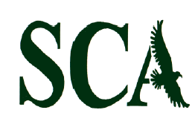

2017 Official league roster – BOYS varsity Soccer

School: Sunbury Christian Academy Head Coach: Jacob Fahringer
Team Colors: hunter green/white
Wins ______ Losses _______ Ties ______ Assistant Coach: tanner Gutelius
Opponent: ___________________________ Assistant Coach: Anderson Renno
Date: ______________________

Players Name | Grade | No. | Position
Nehemiah Courtney | 12 | 11 | Striker (Homeschool)
Seth Kabonick | 12 | 18 | Mid-Field
Chris Schroth | 12 | 9 | Sweeper
Nick Bahner | 11 | 14 | Defense
Conner Carey | 11 | 5 | Goalkeeper
Josh Derk | 11 | 6 | Defense/Mid-Field
Lucas Hoffman | 11 | 31 | Defense/Mid-Field
Ryan Latsha | 11 | 10 | Defense/Mid-Field
Donovan Magnuson | 11 | 34 | Mid-Field
Josiah Miller | 11 | 8 | Mid-Field
Cameron Cinqmars | 10 | 13 | Mid-Field/Goalkeeper
Kyle Hendrickson | 10 | 15 | Defense
Colby Savidge | 9 | 33 | Defense
Alex Sassaman | 8 | 2 | Striker/Defense
Micah Savidge | 8 | 44 | Striker


Official ACAA League Team Roster. to be submitted to the scoreres table before each game.

